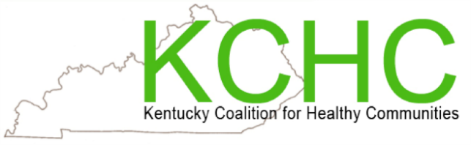
My Health Matters Meeting
Every Monday Night 6:30 – 7:30est PM Via Zoom:

https://uoflhealth.zoom.us/j/93349310683

A weekly support and educational meeting to learn more about good health with fun and open communication.

Sept. 5 No Meeting

Sept. 12, 2022 - Suicide Prevention: Melissa Hopkins, BHDID Frankfort

Sept. 19, 2022 - The Role of Aging Adults to the Younger Generation: Bisola Asola and Andrew Shirota

Sept. 26, 2022 - Healthy Aging: Open Discussion

Please consider joining us and know that you do not have to live in the Louisville area to join us. If you wish to speak at one of our meetings:
Contact Mona Huff at rjhuff01@louisville.edu 502-706-0098

