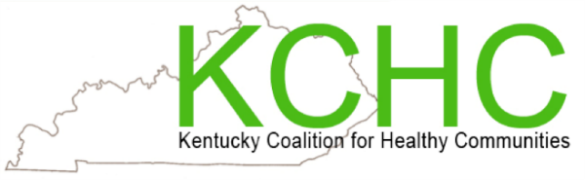

**My Health Matters Meeting**

**Every Monday Night 6:30 – 7:30est PM Via Zoom:**

[https://uoflhealth.zoom.us/j/97372394339](https://nam11.safelinks.protection.outlook.com/?url=https%3A%2F%2Fuoflhealth.zoom.us%2Fj%2F97372394339&data=04%7C01%7Cdarla.handy%40louisville.edu%7Cf69adcbc620f48f98f7208d9fb985744%7Cdd246e4a54344e158ae391ad9797b209%7C0%7C0%7C637817453981534144%7CUnknown%7CTWFpbGZsb3d8eyJWIjoiMC4wLjAwMDAiLCJQIjoiV2luMzIiLCJBTiI6Ik1haWwiLCJXVCI6Mn0%3D%7C3000&sdata=M4yVcfL0HOlJoudbkrpnvSJ9bGIqXLhSqxK0QODEu%2FI%3D&reserved=0)

**A weekly support and educational meeting to learn more about good health with fun and open communication.**

**No Meeting**

**July 11, 2022: How to Experience Compassion In Your Life: Stephanie Vander Souwen**

**July 18, 2022: How to Experience Resilience In Your Life: Barbara Gordon and Miceli, Chelsea**

**July 25, 2022: How to Experience Acceptance In Your Life:**

**Bobbi Bledsoe**

**Please consider joining us and know that you do not have to live in the Louisville area to join us. If you wish to speak at one of our meetings:**

**Contact Mona Huff at** [**rjhuff01@louisville.edu**](mailto:rjhuff01@louisville.edu) **502-706-0098**