KCHC County Challenge Walk
Clear Creek Park
717 Burks Branch Rd, Shelbyville
7th Annual County Challenge Walk
Saturday, September 15, 2018

Registration 9:30 A.M. Walking 10-11 A.M. Celebration 11-11:30 AM
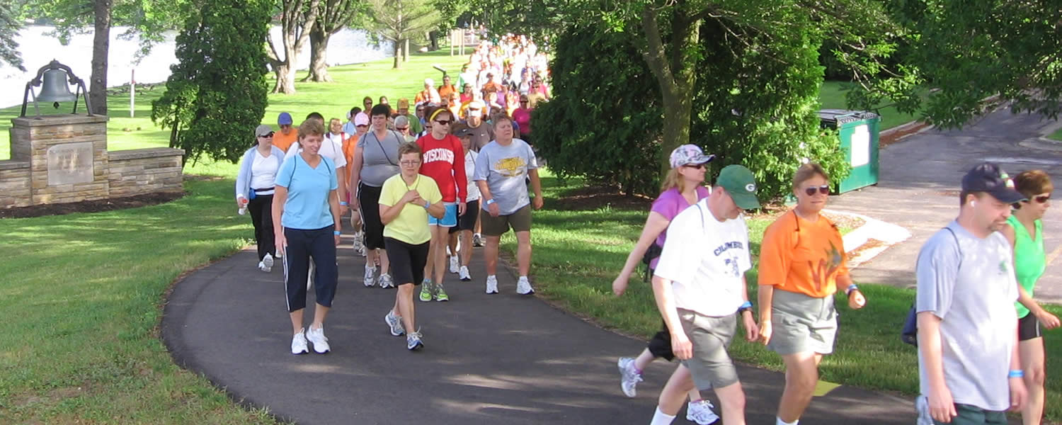
How the walking challenge works!

-Walkers are given a
pedometer at registration or use own device to log steps while walking

-Steps are recorded and tallied once you are finished walking or at 11:00 A.M.

-Medals are awarded by age group for most steps walked and over-all winner at celebration

-Step totals then are compared to challenging counties

- The county with most steps wins the challenge and receives the “Traveling Trophy!”

JOIN family and friends for a

GREAT community event

And PROMOTE Community Pride

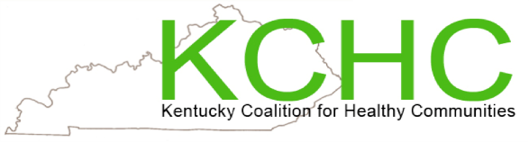

Contact: Amanda Stoess
(502) 633-1243 AmandaN.Stoess@ky.gov

