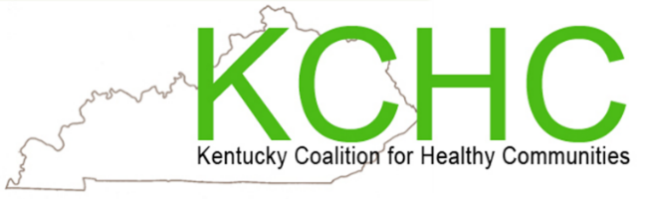

Microclinic International Facilitator Training
December 4 - 5, 2019 ~ 9AM – 4PM
North Central District Administration Building
1020 Henry Clay St. Shelbyville 40065
(Parking and entrance behind building)

Inspire Health in Your Community!
The U of L Trager Institute, Kentucky Coalition for Healthy Communities, North Central District Health Department, and Microclinics International are searching for a limited number of community members and partners in promoting health. Join us in becoming facilitators of the widely successful “Microclinic program.” Apply today. You must fill out application.

Results from previous classes:
- Participants Lost Weight
- Participants Increased Their Physical Activity
- Participants Made Positive Changes to Their Eating Habits (Most reported eating more fruits and vegetables)
- Participants Reported Increased Ability to Manage Current Diagnosis
- Participants Believed They Could Prevent/Delay Chronic Diseases with Better Healthy Behaviors
- Many Participants Were Able to Reduce Medications!
- Many Participants Reported Better Lab Values

SEE THE BACK FOR ADDITIONAL INFORMATION

We want our communities to become healthier!

U of L Trager Institute, Kentucky Coalition of Healthy Communities and North Central District Health Department is teaming up to make it happen!

What is the commitment of a facilitator?
As a facilitator, you will make a commitment to a 2-day sponsored training. (Dec 4-5, 2019) Once trained you will organize and co-lead a class in your community. Classes run continually for one year, meeting once a week for 12- 16 weeks, followed by once a month to meet for a year. Class sizes range with a minimum of approximately 25 program participants. You can inspire and lead your community on a successful health journey!
Become A Trained Microclinics Facilitator: Submit your application by November 27, 2019
Mona Huff 502-706-0098 | rjhuff01@louisville.edu
Darla Handy 270-528-6716 | darla.handy@louisville.edu

Fill out application today! Minimum and maximum numbers to have training.

